An annotation of how Launceston, its Augustinian Priory and Norman castle may have looked during the medieval period.
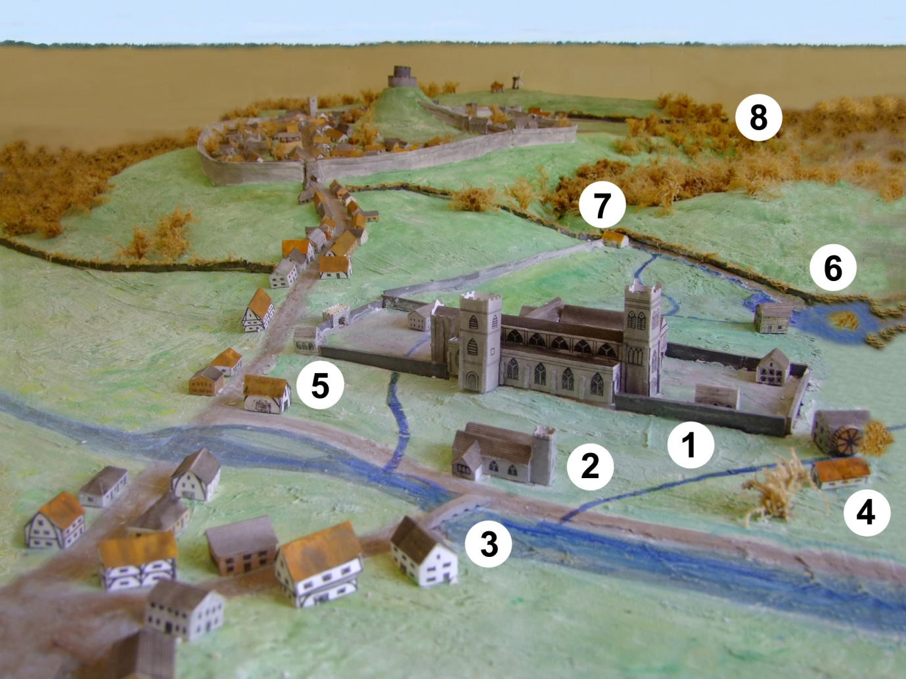
This is a model of Launceston as it was in 1530, which was just before the Dissolution in 1539. It was constructed by Samuel Lunt, and was presented to Launceston’s Lawrence House Museum in 1993 and is on display along with numerous artefacts from the Priory.
Below is how some details listed are recorded in the museum
It is photographed and annotated for us by John Ellacott .

1. The main Priory buildings at Riverside.
2. St Thomas the Apostle Church, which supports an active Anglican congregation.
3. Priors bridge, or some call it the pack horse bridge, is often photographed.
4. Town Mills. You can walk outside this stone building which is opposite the ‘Olde Toll House’ with ‘East Mill’, (part gone for parking) down to Riverside Mills housing. This being the main mill for the Priory, with its own controlled water leat along Kensey Valley hillside to drive the Water Wheels at the rear of the buildings, returning the water to the River Kensey, (now the Bowling Club car park).
5. A small part (staircase window) of St James’ Chapel can be seen at the back of a house from Priory lane which is behind the Steam Railway. St James Chapel is a listed building and you can see details of the listing and a photograph in our History tab; St James’ Chapel. (Priory Lane by Launceston Steam Railway is pedestrian only).
6. A part of the Priory fish pond is in the front garden of a private house called Priory Mere. The central island still exists. This mediaeval fish pond was mostly fed from water coming from the St Catherine’s hill area. Fish from the pond, mainly Carp, will have been used to supplement people’s diet. The pond waterfall outlet can be seen from Tredydan Road, which drove a horizontal water wheel for the blacksmiths, now buried under ‘4 Old Wooda’ drive.
7. The site of Maiden’s Well was in Wooda Lane although there are no remains left now. This was a junction of the leat and water could be diverted by a sluice gate to the Priory pond when needed to keep the fish alive or flood alongside Wooda (and now piped under Priory Park), to the River Kensey.
8. The site of St. Johns Chapel now Chapel Close with no remains, the stream to the Priory leat system can be followed by public footpath to Maiden’s Well. You can find it via Carboth Lane or Western Terrace. Locally the area is pronounced ‘Chayple’. The St John’s name is retained as a housing estate area bordering the A388 and the A30.

